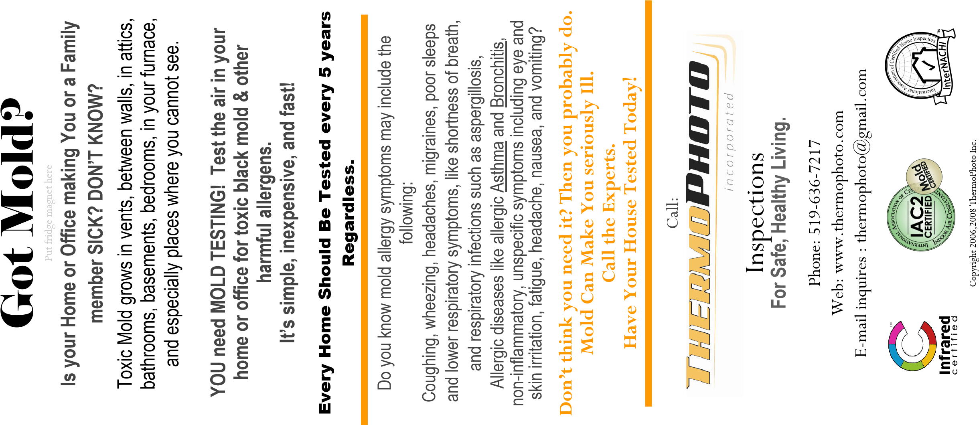
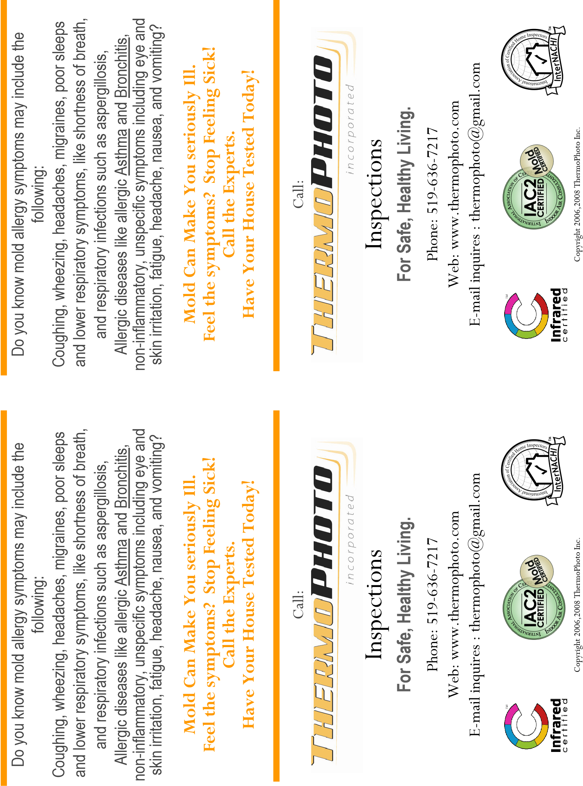
Is your Home or Office making You or a Family
member SICK? DON’T KNOW?
YOU need MOLD TESTING? Test the air in your
home or office for toxic black mold & other
harmful allergens.
It’s simple, inexpensive, and fast!
Got Mold?
Toxic Mold grows in vents, between walls, in attics
,
bathrooms, basements, where you sleep, in your
furnace, and especially places where you cannot see
.

Is your Home or Office making You or a Family
member SICK? DON’T KNOW?
YOU need MOLD TESTING? Test the air in your
home or office for toxic black mold & other
harmful allergens.
It’s simple, inexpensive, and fast!
Got Mold?
Toxic Mold grows in vents, between walls, in attics
,
bathrooms, basements, where you sleep, in your
furnace, and especially places where you cannot see
.

