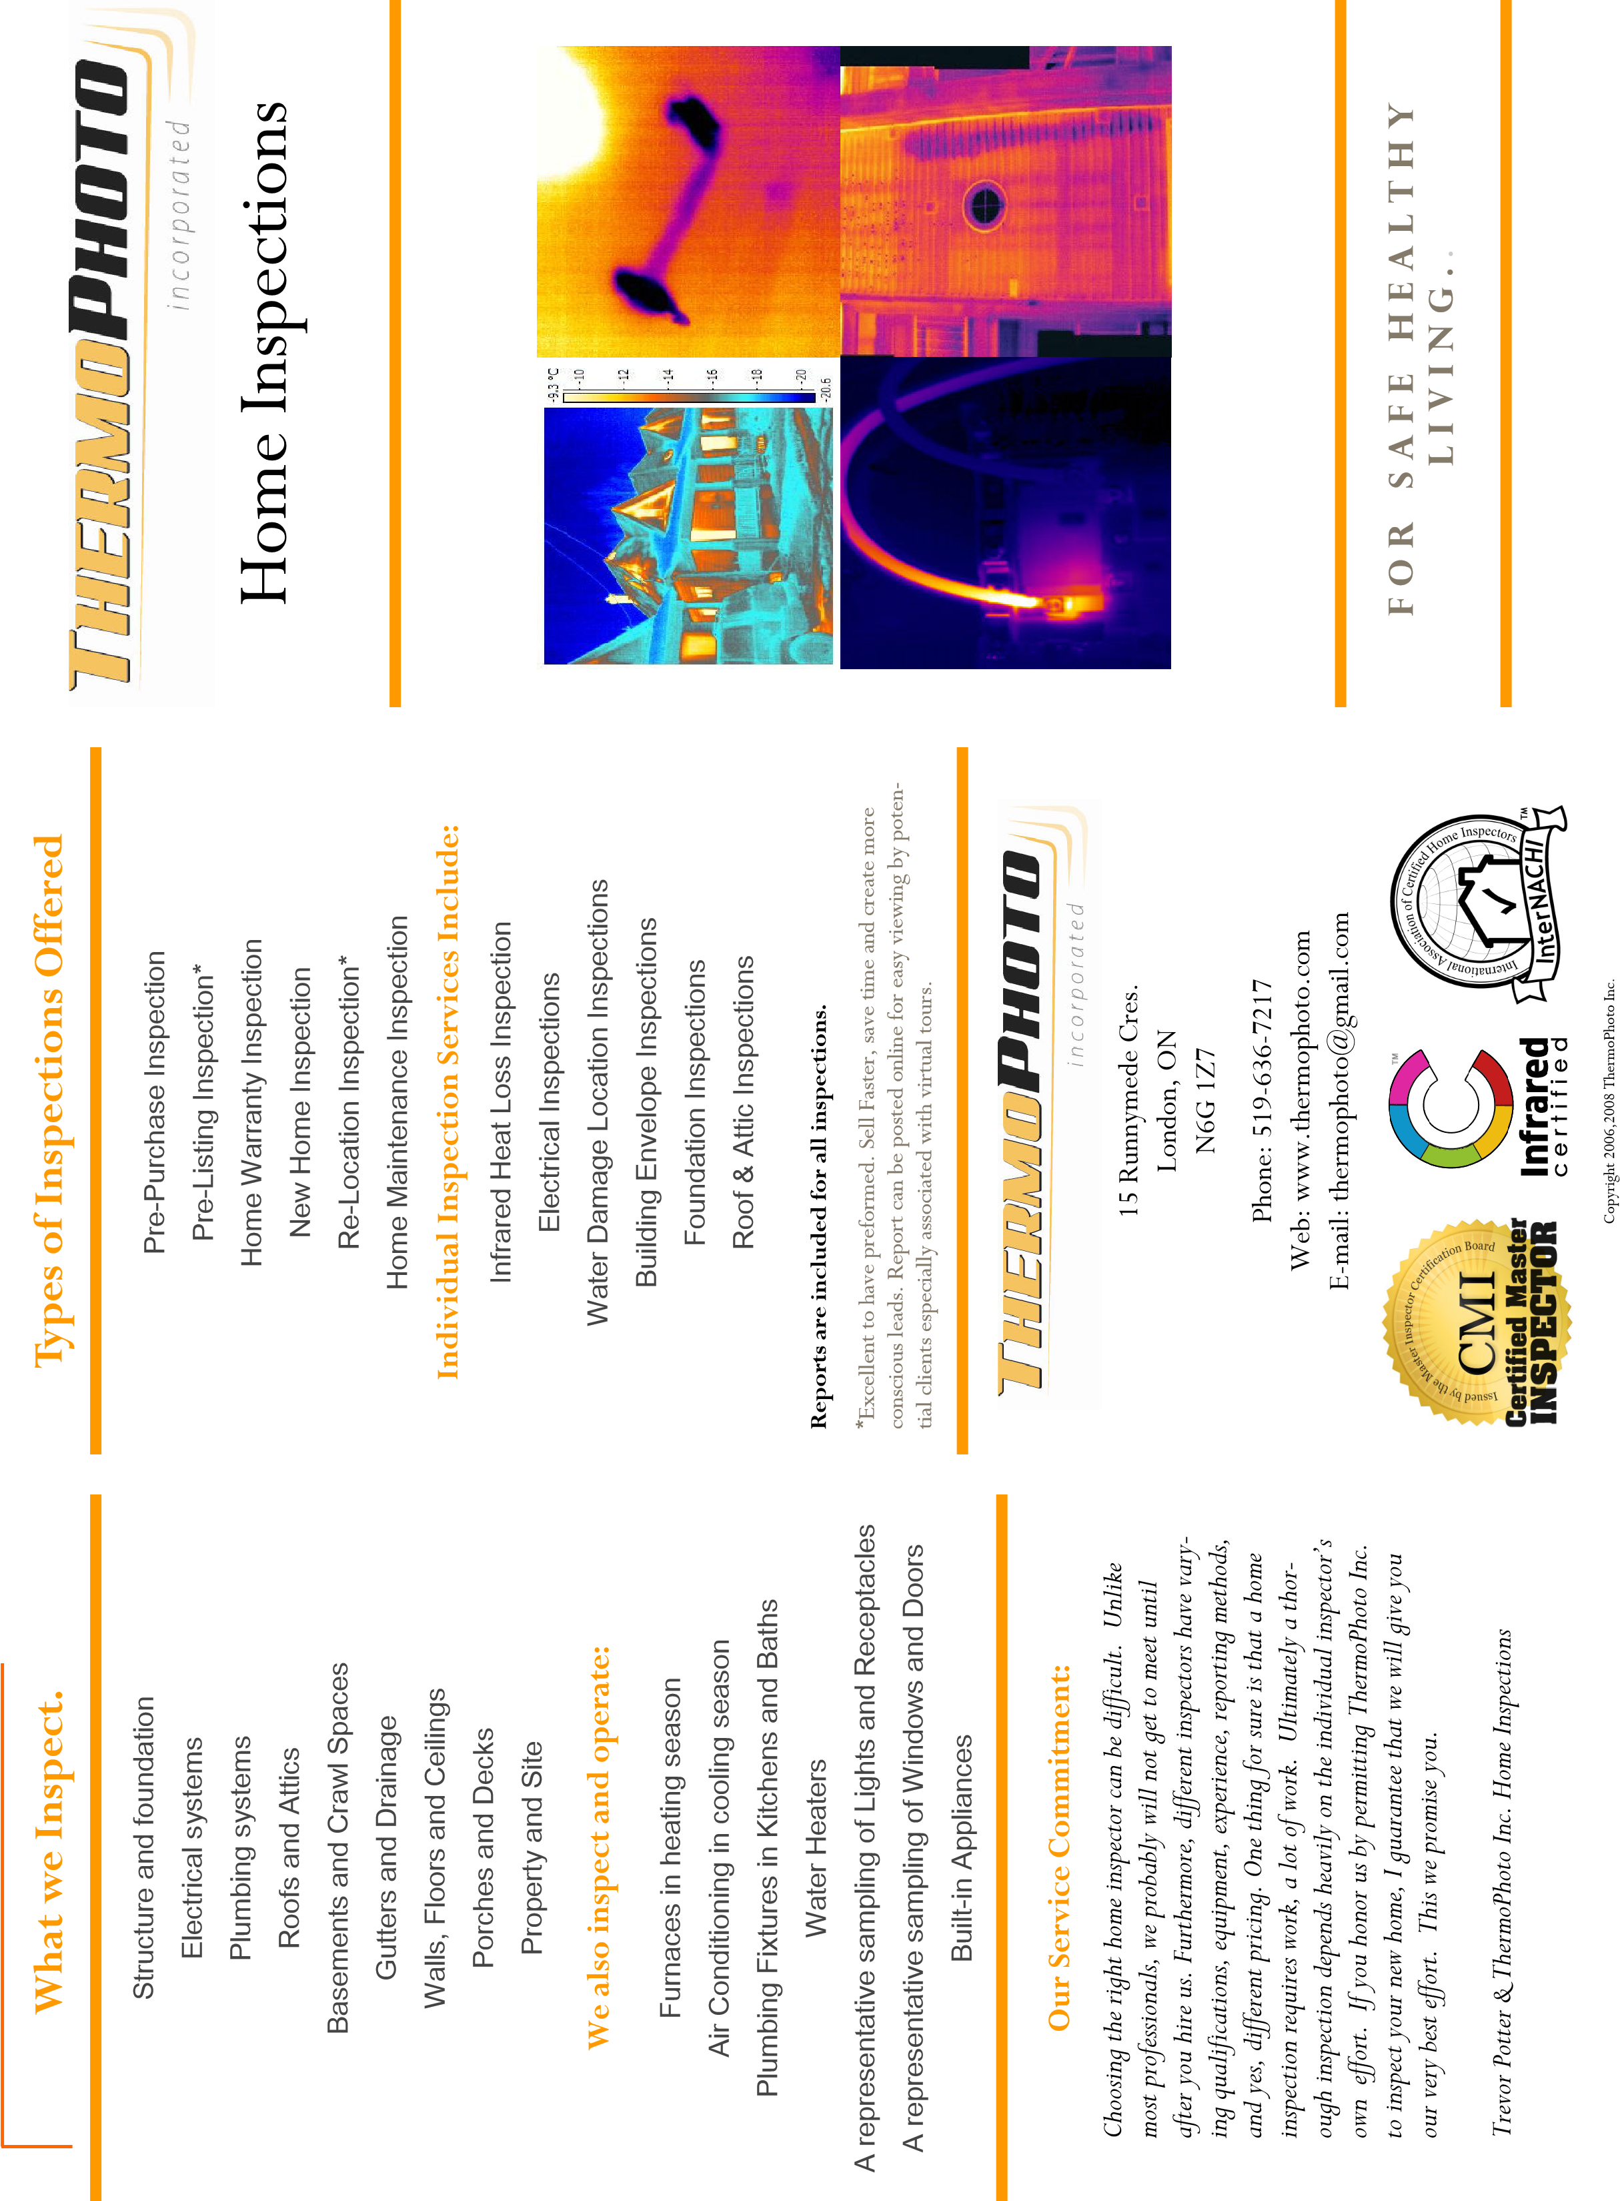
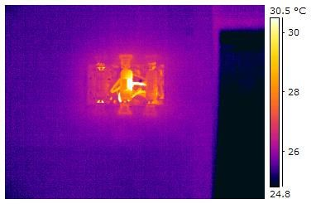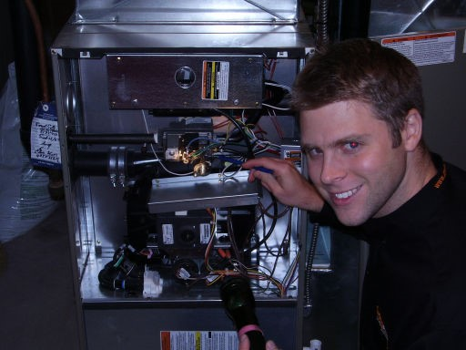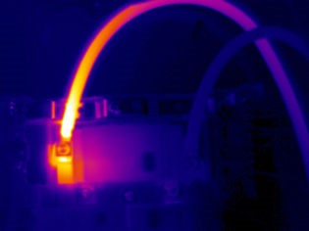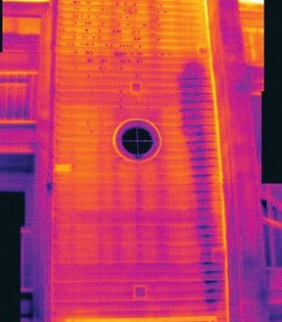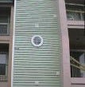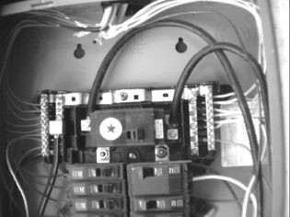
Heated Aluminum wiring at
switch receptacle.
•
Roof, vents, flashings, and trim.

•
Gutters and downspouts.

•
Skylight, chimney and other roof penetrations.

•
Decks, stoops, porches, walkways, and railings.

•
Eaves, soffit and fascia.

•
Grading and drainage.

•
Basement, foundation and crawlspace.

•
Water penetration and foundation movement.

•
Heating systems.

•
Cooling systems.

•
Main water shut off valves.

•
Water heating system.

•
Interior plumbing fixtures and faucets.

•
Drainage sump pumps with accessible floats.

•
Electrical service line and meter box.

•
Main disconnect and service amperage.

•
Electrical panels, breakers and fuses.

•
Grounding and bonding.

•
GFCIs and AFCI’.

•
Fireplace damper door and hearth.

•
Insulation and ventilation.

•
Garage doors, safety sensors, and openers.

•
And much more.

Individual Services:
ThermoPhoto Inc. gets called by all types of indus-
try to inspect various buildings, residences, ma-
chinery, electrical systems, properties, boats, and

etc..
Individual services are available to identify, loca
te,
and isolate suspect conditions throughout your
residential system. Before you have a contractor
tell you what has to
be done Call us for an
unbiased inspection
today!.
“My roofer says I have
to have the roof re-
placed, but my in-
spector says I only
need a patch job…”
An unbiased approach is generally the honest one!
Furnace inspection
Infrared inspections can identify and document:

Electrical faults before they cause a fire.
Overloaded and undersized circuits.
Circuit breakers in need of immediate replacement.
Missing, damaged, and/or wet insulation.
Heat loss and air infiltration in walls, ceilings,
floors,
Windows and doors.
Water and moisture intrusion that could lead to mol
d.
Possible pest infestation.
Hidden roof leaks, before they cause serious damage
.
Air conditioner compressor leaks.
Under fastening and/or missing framing members.
Structural defects.
Broken seals in double pane windows.
Energy loss and efficiency.
Dangerous flue leaks.
Damaged and/or malfunctioning radiant heating syste
ms.
Unknown plumbing leaks.
Overheated equipment.
Loose lug screw, creating electrical arc, a
potential shock and fire hazard.
Visible water inside building envelope.
Our Full Home Inspections include:
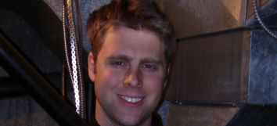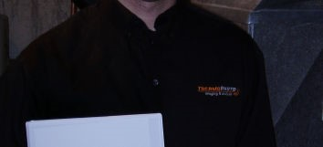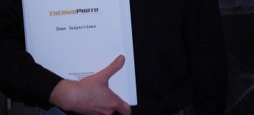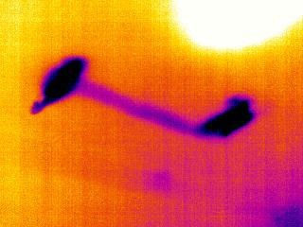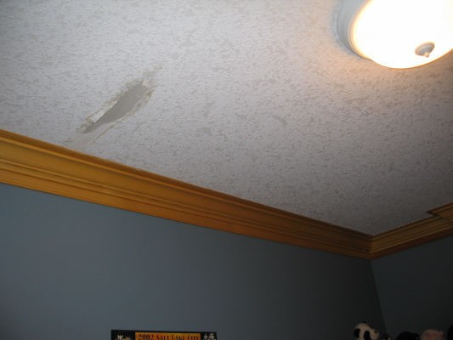
A home inspection is just one
of the many important steps
in the process of buying a
home. Buying a home is
probably one of the most im-
portant purchases of your life.
Why not protect your invest-
ment by having a Certified
Master Inspector inspect be-
fore you purchase. Our in-
spectors are highly trained, experienced and certi-
fied. We will look for and identify deficiencies
which may be unscheduled, costly, or become a
future headache.
In these times of
‘Buyer Beware’
you owe it to
yourself to take responsibility into your own
hands. Take the worry away and give yourself
piece of mind. Hire the professionals at Thermo-
Photo Inc. Home Inspections… ‘
We’ll look for
things you never thought of.’

†Free Infrared Inspections
ThermoPhoto Inc. Home Inspections offers
infrared inspection services free of charge to our
clients in addition to a home inspection. Thermo-
Photo Inc. provides
the most comprehen-
sive home inspection
available in London
and surrounding area
at comparable rates.

Buyer Beware
Water damage visible in
infrared view but not in
normal sight.
†Free Infrared Inspections excludes Thermographic Energy
Audit (TEA), includes
water damage, pest & rodent, and electrical inspection
s. TEA may be purchased as
an ancillary service.

