
Clean
Home

Treatment
For Safe
,
Healthy

Living
Ozone shock treatment
Protection from biological threats.


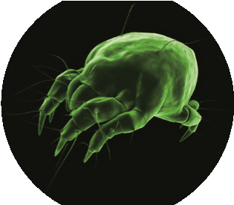
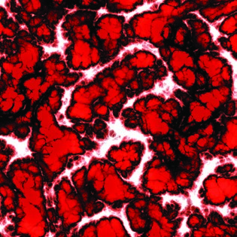
for
Safe,
Healthy

Living
Copyright 2006-2009 Thermophoto Inc.
For a free no obligation quote please call:

519-636-7217

www.thermophoto.com
for Safe
,
Healthy

Living
Mold,

bacteria,

odour?

Kill, disinfect and eliminate the threat of:

Visible black and toxic mold

Harmful VOC’s and allergens

Bacteria, virus, ecoli

Dust mites, bedbugs, fleas, lice

Bad odours:
smokey, musty, pet, vomit, & more
We treat:

Whole homes or individual rooms:

Including attics, basements, and apartments

Office and Work spaces

Boats, cars and trailers

Banquet halls, kitchens, bars and restaurants.
Safe and effective work, GuaranteeD.
Treatment is 100% natural & leaves a fresh scent.
Eliminates microbiological threats & odours.
Eliminates
the threat of mold and
other harmful allergens even inside
your duct system.
Kills 99.9%
of harmful bacterias &
viruses which cause sickness & odours.
Terminates
dust mites, fleas, lice,
bed bugs and other house hold pests.

